# Building Mobile App

**1.Create an HTTP request to communicate with Mobile App**

| Date | 17 November 2022 |
| --- | --- |
| Team ID | PNT2022TMID26825 |
| Project Name | project-Real Time River Water Quality Monitoring And Control System |
| Maximum Marks | 4 Mks |

# HTTP request:

HTTP transfers data in a hypertext format between the browser and the

web server, whereas HTTPS transfers data in an encrypted format. As a result, HTTPS protects websites from having their information broadcast in a way that anyone eavesdropping on the network can easily see. During the transit between the browser and the web server, HTTPS protects the data from being accessed and altered by hackers. Even if the transmission is intercepted, hackers will be unable to use it because the message is encrypted.

1. Private Key: It is used for the decryption of the data that has been encrypted by the public key. It resides on the server-side and is controlled by the owner of the website. It is private in nature.
2. Public Key: It is public in nature and is accessible to all the users who communicate with the server. The private key is used for the decryption of the data that has been encrypted by the public key.

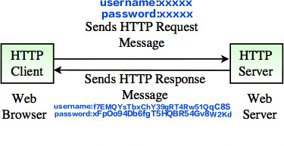

1. Ensuring that the browser communicates with the required server directly.
2. Ensuring that only the communicating systems have access to the messages they exchange

